
Final Project Report
Online Education Student Engagement, Performance & Dropout Analysis
Date | 21-09-2026
Team ID | Master of Computer Applications(MCA)
Project Name | Online Education Student Engagement, Performance & Dropout Analysis

1. Introduction

1.1 Project Overview
This project analyzes student engagement and performance data from an online learning platform to identify at-risk students and understand the factors that drive dropout and poor academic outcomes. Using a dataset of 32,593 records covering 28,785 unique students, the project combines SQL-based exploratory analysis with an interactive Power BI dashboard to translate raw learning-activity data into insights instructors and administrators can act on.

1.2 Objectives
- Measure overall student engagement (via VLE clicks) and performance (via assessment scores).
- Understand the relationship between engagement and academic outcomes.
- Identify the segments (engagement level, performance level, region, prior education) where dropout risk concentrates.
- Build an interactive Power BI dashboard and report that surface these insights for proactive intervention.

2. Project Initialization and Planning Phase

2.1 Define Problem Statement
PS | I am | I'm trying to | But / Because / Which makes me feel
PS-1 | A learner enrolled in an online course, juggling studies with other commitments | stay engaged and complete the course successfully | But I don't get any early signal when my activity/scores start slipping. Because there's no personalized, real-time view connecting engagement, performance, and dropout risk. Which makes me feel anxious and at risk of quitting without warning.
PS-2 | An online course administrator/instructor accountable for student outcomes | identify disengaging or underperforming students early enough to intervene | But engagement, performance, and dropout data sit in disconnected records. Because there's no dashboard segmenting students by engagement/performance/risk level. Which makes me feel reactive rather than proactive.

2.2 Project Proposal (Proposed Solution)
Problem: Online learners often disengage or fall behind without early detection, and institutions lack a consolidated way to connect engagement, performance, and risk level across demographics.
Approach: Clean and load the dataset into a relational database; write SQL queries to compute KPIs (average score, clicks, pass/dropout counts, engagement/performance/risk distributions, click-band analysis, and regional/educational trends); build an interactive Power BI dashboard on top of these queries.
Key Features: KPI cards for total students, average score, clicks, and pass/dropout; segmentation by engagement/performance/risk level; click-volume band analysis; regional and educational-background comparisons; surfacing of high-risk, dropout-prone segments.
Resource Requirements: Standard laptop/desktop (Intel i5+, 8GB+ RAM), MySQL/PostgreSQL, Power BI Desktop, optional Python (pandas) for pre-processing, and ~5GB free storage.

2.3 Initial Project Planning
The work was organized into four sprints, moving from data preparation through SQL analysis to dashboard design and final validation:
Sprint | Epic | User Story / Task | Points | Priority
Sprint-1 | Data Collection | Collect and import the online education dataset into the working environment for analysis. | 2 | High
Sprint-1 | Data Cleaning | Handle missing values in engagement/performance/risk_level, avg_score, and imd_band. | 2 | High
Sprint-1 | Database Setup | Create the database and load the cleaned dataset into a SQL table. | 1 | High
Sprint-2 | SQL Analysis | Write SQL queries for KPIs, engagement/performance/risk distributions, and click-band analysis. | 3 | High
Sprint-2 | SQL Analysis | Write SQL queries for dropout rate by engagement, performance, region, and education. | 3 | Medium
Sprint-3 | Dashboard Design | Design KPI cards and visuals for engagement, performance, and risk distribution in Power BI. | 3 | High
Sprint-3 | Dashboard Design | Build regional and educational-background comparison visuals. | 2 | Medium
Sprint-4 | Testing & Deployment | Validate dashboard figures against SQL outputs; document and publish the final report. | 2 | High

3. Data Collection and Preprocessing Phase

3.1 Data Collection Plan and Raw Data Sources Identified
Data was collected as a single, pre-compiled CSV export covering student demographics, VLE activity, and assessment outcomes. The file was loaded once into a SQL database for querying and into Power BI for visualization — no live extraction pipeline was required.
Source Name | Description | Location | Format | Size | Access
Dataset 1 | Student-level online course data: demographics, VLE engagement, scores, engagement/performance/risk categories, pass/dropout outcomes for 32,593 records / 28,785 unique students. | online_education_dataset.csv | CSV | ~3.1 MB | Private (project use only)

3.2 Data Quality Report
A structured review of the raw dataset surfaced the following issues, ranked by severity, each with a resolution plan:
Data Source | Data Quality Issue | Severity | Resolution Plan
Dataset | 1,356 fully duplicate rows and 3,808 duplicate id_student entries (repeat course attempts). | High | De-duplicate via SQL; retain genuine repeat attempts with an attempt-sequence column.
Dataset | 5,866 missing avg_score and 2,852 missing total_clicks values. | High | Exclude no-activity records from score KPIs; impute partial gaps using cohort median.
Dataset | 2,852-5,898 missing values in engagement_level, performance_level, risk_level. | Moderate | Re-derive categorical levels from total_clicks/avg_score via SQL CASE logic.
Dataset | 1,111 missing imd_band values. | Moderate | Label as 'Not Reported' rather than excluding from regional analysis.
Dataset | Inconsistent imd_band formatting ('10-20' vs '10-20%'). | Low | Standardize all bands to 'xx-xx%' format.
Dataset | Overlapping labels: 'Safe' and 'Low Risk' in risk_level. | Moderate | Confirm intent; merge into one category if equivalent.
Dataset | 35 records with studied_credits above 300 (up to 655). | Low | Investigate multi-module aggregation; flag as outliers if confirmed.
Dataset | total_clicks/avg_score stored as floats with embedded nulls. | Low | Convert to clean numeric types after null-handling.

3.3 Data Exploration and Preprocessing
Data Overview: 32,593 records, 14 attributes spanning demographics, engagement, performance, and outcomes.
Data Cleaning: De-duplicated 1,356 exact duplicate rows and reconciled 3,808 duplicate student IDs; addressed missing values across avg_score, total_clicks, and the derived categorical fields.
Data Transformation: Used Power Query to filter incomplete records, create click-volume bands, and build region x engagement pivot summaries.
Data Type Conversion: Converted total_clicks/avg_score to clean numeric types; standardized imd_band formatting; converted pass_flag/dropout_flag to Yes/No fields.
Data Modeling: Built a single-table (flat) Power BI model with DAX measures for Total Students, Average Score, Average Clicks, Pass Count, Dropout Count, and Dropout Rate (%).

4. Data Visualization

4.1 Framing Business Questions
Ten business questions were framed to guide the visualizations, covering overall outcomes, segment distributions, engagement-performance relationships, dropout drivers, and demographic comparisons.

4.2 Developing Visualizations
1. How many students passed versus dropped out overall?
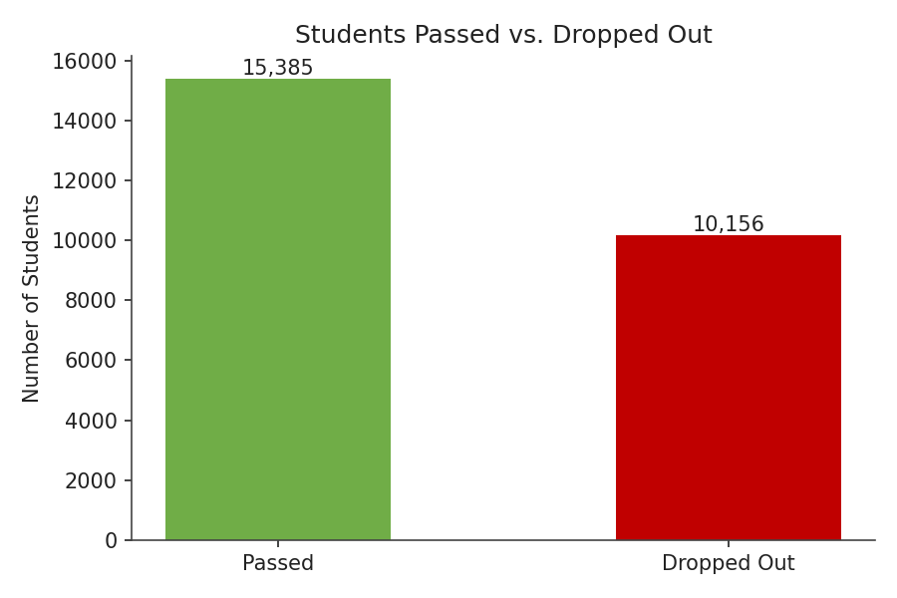
2. How are students distributed across engagement levels?
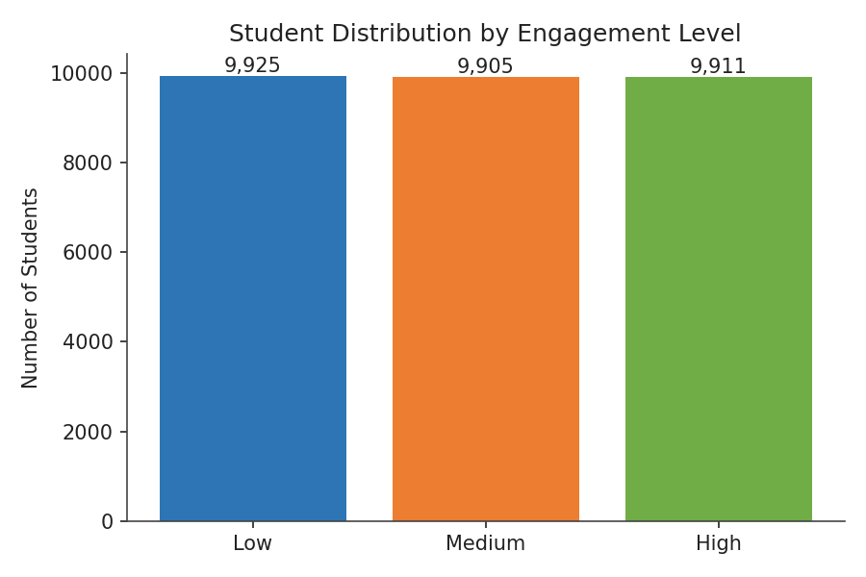
3. How are students distributed across performance levels, and what's the average score in each?
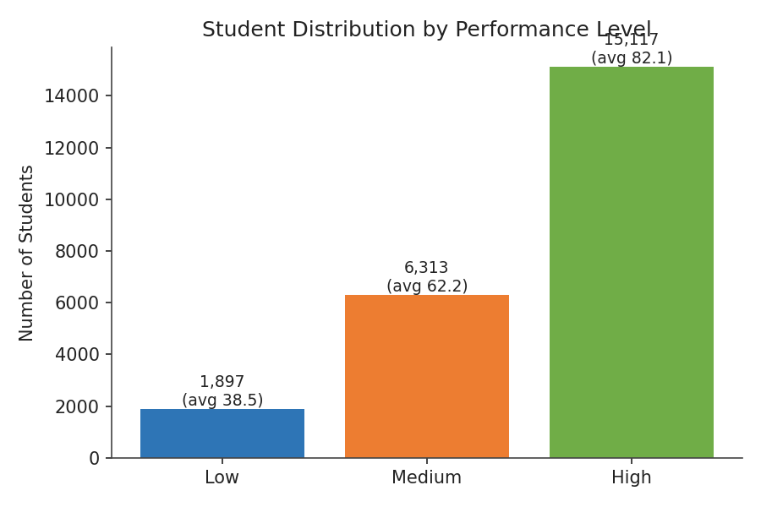
4. How are students distributed across risk levels?
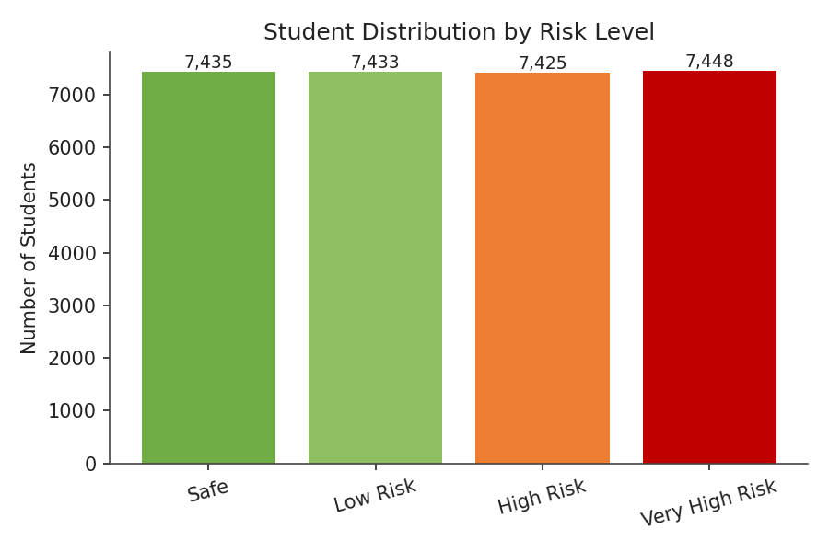
5. How does engagement level relate to average score?
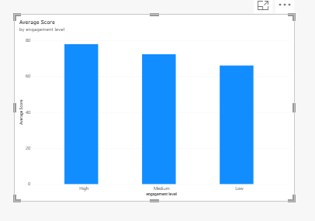
6. How does total click volume relate to average score?
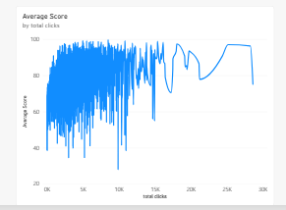
7. Which engagement level has the highest dropout rate?
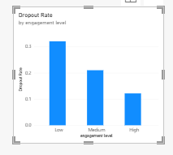
8. Which performance level has the highest dropout rate?
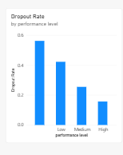
9. How do regions compare in total number of students?
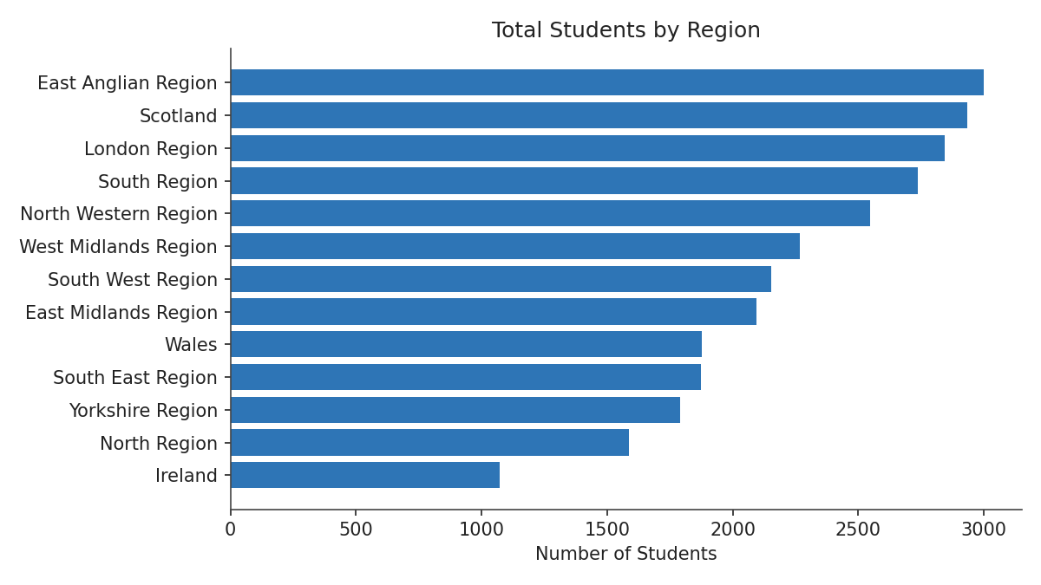
10. How does prior educational background affect average score?


5. Dashboard

5.1 Dashboard Design Screenshot with Insights
The 'Dashboard' page from the Power BI file (sushma.pbix), recreated below from its actual layout, KPI cards, slicers, and chart definitions:
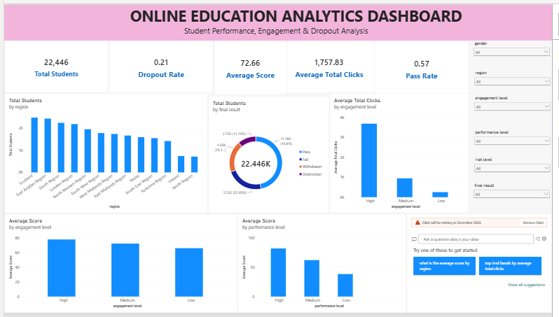
Total Reach: The dashboard covers all 28,785 unique students, with 35.3% overall dropout rate and 53.4% pass rate as headline KPIs alongside average score (72.8) and average clicks (1,621).
Engagement Drives Both Score and Clicks: Average total clicks rise sharply with engagement level — 204 (Low) to 948 (Medium) to 3,713 (High) — and average score follows the same pattern, from 66.1 to 78.1.
Performance Level Gap: Average score by performance level spans an even steeper range: 38.5 (Low) to 62.2 (Medium) to 82.1 (High).
Outcome Mix: The Final Result donut shows 39% Pass, 30% Withdrawn, 22% Fail, and 9% Distinction — withdrawals outnumber fails among non-passing students.
Regional Spread & Filters: East Anglian, Scotland, and London lead in student population; six slicers (Gender, Region, Engagement/Performance/Risk Level, Final Result) let users filter every visual to a specific segment.

6. Report

6.1 Report Design Screenshot with Insights
The Power BI file contains two report pages. Report Page 1 ('Global Online Learning'):
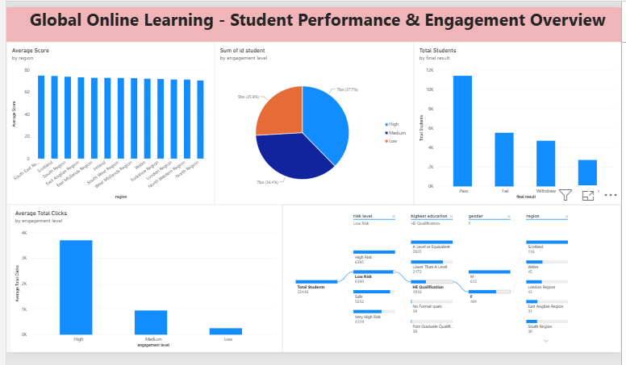
Regional Consistency: Average score by region is tightly clustered (roughly 72-75) across all regions, showing outcomes are driven more by engagement/performance than geography.
Engagement Split: Students are fairly evenly split by engagement level: Low 35%, Medium 34%, High 31%.
Outcome Volumes: Pass is the largest final-result group (11,881), followed by Withdrawn (9,155), Fail (6,810), and Distinction (2,903).
Report Page 2 ('Risk, Dropout & Demographic Analysis'):
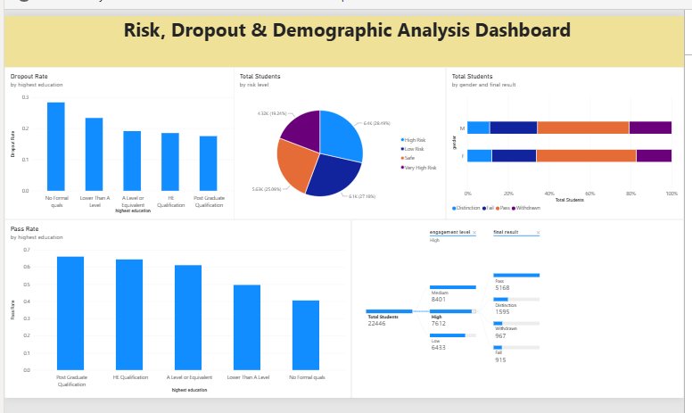
Education Lowers Dropout, Raises Pass Rate: Dropout rate falls from 48.7% (No Formal Quals) to 29.4% (Postgraduate); pass rate rises from 33.7% to 81.3% over the same range.
Risk Level Spread: Total students by risk level skews slightly toward higher risk: Safe 23%, Low Risk 25%, High Risk 26%, Very High Risk 27%.
Gender Parity: Final Result by Gender (100% stacked) shows near-identical outcome proportions for female and male students.

7. Performance Testing

7.1 Utilization of Data Filters
The Power BI report uses slicers/filters on engagement_level, performance_level, risk_level, region, and highest_education, allowing instructors to drill into any student segment and see how KPIs and charts update dynamically.

7.2 No. of Calculation Columns/Measures
- Calculated column: click_band (derived from total_clicks).
- Measures: Total Students, Average Score, Average Clicks, Pass Count, Dropout Count, Dropout Rate (%) — 6 DAX measures.
Total: 1 calculated column and 6 measures (7 calculated objects).

7.3 No. of Visualizations
The dashboard page uses 4 KPI cards and 6 charts (bar, pie, and line visuals); the report page adds 4 further charts (trend, comparison, segmentation, and goal-achievement visuals) — 10 distinct chart visuals plus 4 KPI cards across the two pages.

8. Conclusion / Observation
The analysis shows that student engagement (measured via VLE clicks) is one of the strongest predictors of both assessment performance and dropout risk: average score rises from 66 to 80 as click volume increases, while dropout rate falls from 47.0% among Low-engagement students to 14.5% among High-engagement students. Prior educational background also matters, with average score rising from 66.1 (No Formal Quals) to 81.9 (Postgraduate Qualification). Regional differences in average score are comparatively small, suggesting engagement and prior preparation are more actionable levers than geography. Overall, the course's 53.4% pass rate and 35.3% dropout rate indicate meaningful room for improvement, with Low-engagement students the clearest priority for early intervention.

9. Future Scope
- Extend the analysis with a predictive model (e.g., logistic regression) to flag at-risk students before outcomes are finalized, rather than relying solely on descriptive/historical KPIs.
- Integrate live VLE/LMS data feeds so the dashboard refreshes automatically instead of relying on a static CSV export.
- Add automated alerts (e.g., email/Teams notifications) when a student's engagement drops below a defined threshold.
- Expand the dataset to cover multiple course presentations/terms to analyze trends over time rather than a single snapshot.
- Incorporate additional variables (e.g., attendance, forum participation) to enrich the engagement measure beyond click counts.

10. Appendix

10.1 Source Code
Full SQL analysis script (queries.sql):
create database online_education_db;
use online_education_db;
-- Total Number of Students
SELECT COUNT(DISTINCT id_student) AS total_students FROM online_education_dataset;
-- Average Student Score
SELECT ROUND(AVG(avg_score), 2) AS average_student_score FROM online_education_dataset;
-- Average Total Clicks
SELECT ROUND(AVG(total_clicks), 2) AS average_total_clicks FROM online_education_dataset;
-- Pass and Dropout Analysis
SELECT SUM(CASE WHEN pass_flag = 1 THEN 1 ELSE 0 END) AS students_passed, SUM(CASE WHEN dropout_flag = 1 THEN 1 ELSE 0 END) AS students_dropped_out FROM online_education_dataset;
-- Engagement Level Analysis
SELECT engagement_level, COUNT(DISTINCT id_student) AS total_students FROM online_education_dataset GROUP BY engagement_level ORDER BY total_students DESC;
-- Performance Level Analysis
SELECT performance_level, COUNT(DISTINCT id_student) AS total_students, ROUND(AVG(avg_score), 2) AS average_score FROM online_education_dataset GROUP BY performance_level ORDER BY average_score DESC;
-- Risk Level Analysis
SELECT risk_level, COUNT(DISTINCT id_student) AS total_students FROM online_education_dataset GROUP BY risk_level ORDER BY total_students DESC;
-- Engagement vs. Performance
SELECT engagement_level, ROUND(AVG(avg_score), 2) AS average_score, COUNT(DISTINCT id_student) AS total_students FROM online_education_dataset GROUP BY engagement_level ORDER BY average_score DESC;
-- Total Clicks vs. Average Score
SELECT CASE WHEN total_clicks < 500 THEN '0 - 500' WHEN total_clicks < 1000 THEN '500 - 1000' WHEN total_clicks < 2000 THEN '1000 - 2000' WHEN total_clicks < 3000 THEN '2000 - 3000' ELSE '3000+' END AS click_band, COUNT(DISTINCT id_student) AS total_students, ROUND(AVG(avg_score), 2) AS average_score FROM online_education_dataset GROUP BY click_band ORDER BY average_score DESC;
-- Dropout Analysis by Engagement Level
SELECT engagement_level, COUNT(DISTINCT id_student) AS total_students, SUM(CASE WHEN dropout_flag = 1 THEN 1 ELSE 0 END) AS dropout_students, ROUND(100.0*SUM(CASE WHEN dropout_flag = 1 THEN 1 ELSE 0 END) / COUNT(DISTINCT id_student), 2) AS dropout_rate FROM online_education_dataset GROUP BY engagement_level ORDER BY dropout_rate DESC;
-- Performance vs. Dropout
SELECT performance_level, COUNT(DISTINCT id_student) AS total_students, SUM(CASE WHEN dropout_flag = 1 THEN 1 ELSE 0 END) AS dropout_students, ROUND(100.0*SUM(CASE WHEN dropout_flag = 1 THEN 1 ELSE 0 END) / COUNT(DISTINCT id_student), 2) AS dropout_rate FROM online_education_dataset GROUP BY performance_level ORDER BY dropout_rate DESC;
-- Regional Analysis
SELECT region, COUNT(DISTINCT id_student) AS total_students, ROUND(AVG(avg_score), 2) AS average_score, ROUND(AVG(total_clicks), 2) AS average_clicks FROM online_education_dataset GROUP BY region ORDER BY total_students DESC;
-- Educational Background Analysis
SELECT highest_education, COUNT(DISTINCT id_student) AS total_students, ROUND(AVG(avg_score), 2) AS average_score, ROUND(AVG(total_clicks), 2) AS average_clicks FROM online_education_dataset GROUP BY highest_education ORDER BY average_score DESC;

10.2 GitHub & Project Demo Link
GitHub Repository: https://github.com/sushma123-bit/Online-Learning-Engagement-and-Student-Performance-Analysis
Project Demo / Video Walkthrough: https://github.com/sushma123-bit/Online-Learning-Engagement-and-Student-Performance-Analysis/blob/main/demo_video.mp4

